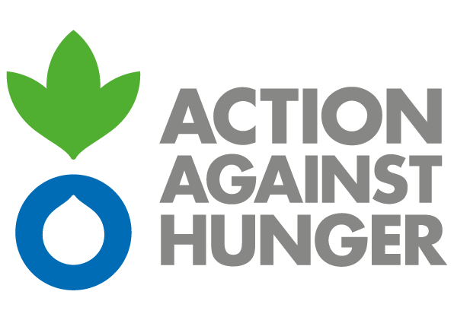 | Action Against Hunger  Mission Sudan

ADVERTISEMENT

SDF7AB EMERGENCY ASSISTANCE TO THE MOST VULNERABLE POPULATION IN CENTRAL DARFUR AND SOUTH KORDOFAN STATES

PD: SDKH00018

Action Against Hunger tackles the causes and effects of hunger and diseases that threaten the lives of vulnerable children, women and men.
Established in France in 1979, Action Against Hunger are a nongovernmental, non-political, non-religious, non-profit organisation.

Action Against Hunger- Sudan intends to award a Contract for the supply of food items (oil, sugar, iodisedsalt, lentils, millet flour) in the framework of humanitarian programs funded by SIDA.

Bidding documents can be obtained by interested parties from :

Mohamed Younis
Logistics Manager

tel :+249 (0) 999 470 965
email: mosman@sd.acfspain.org

Action Against Hunger does not bind itself to award the tender to the lowest tender or any bid and reserves the right to accept the whole or part of the tender.

The tender documentation can be collected from June 30th2020 from 9am (Khartoum time).
The deadline for submission of tenders is July 14th2020 at 14pm (Khartoum time).

